Part Number: PU322-42165-WH

Kit Contents
Item # | Quantity Reqd. | Description
1 | 1 | Module Trailer Harness
2 | 1 | 4-Flat Trailer Harness
3 | 1 | Mounting Bracket: 4-Flat
4 | 2 | Screw #10-24
5 | 2 | Nut/Washer #10-24
6 | 45 | Wire Tie: 8”
7 | 1 | Wire Tie: Stud Mount (M6)
8 | 4 | Wire Tie: 14”
9 | 1 | Wire Tie: Push Mount Clip (Grey)
10 | 6 | Foam Pad
11 | 1 | Fuse Location Card
Hardware Bag Contents
Item # | Quantity Reqd. | Description
1
2
3
Additional Items Required For Installation
Item # | Quantity Reqd. | Description
1 | 1 | Tow Hitch
2
3
Conflicts
Gas (non-hybrid) vehicles & SE models
General Applicability
2016 and later RAV4 Hybrid models except SE grade
Recommended Sequence of Application
Item # | Accessory
1 | Module Trailer Harness
2 | Towing Hitch
3 | 4-Flat Trailer Harness
*Mandatory
Vehicle Service Parts (may be required for reassembly)
Item # | Quantity Reqd. | Description
1
2
3
Recommended Tools
Personal & Vehicle Protection | Notes
Safety Glasses
Safety Shoes
Blankets
Special Tools | Notes
Installation Tools | Notes
Wrench | 10mm
Ratchet | ⅜” Drive
Extension | ⅜” Drive, Medium
Socket | 10mm, 14 mm ⅜” Drive
Screwdriver | Phillips #2
Drill
Drill Bit | 7.5mm
Side Cutter
Plastic Trim Removal Tool
Tape Measure
Flashlight
Torque Wrench | 5.4 N-m (48 in-lbf)  8.4 N-m (74 in-lbf)  42 N-m (371 in-lbf)
Special Chemicals | Notes
Cleaner
Legend
STOP: Damage to the vehicle may occur. Do not proceed until process has been complied with.
OPERATOR SAFETY: Use caution to avoid risk of injury.
CAUTION: A process that must be carefully observed in order to reduce the risk of damage to the accessory/vehicle and to ensure a quality installation.
TOOLS & EQUIPMENT: Used in Figures calls out the specific tools and equipment recommended for this process.
REVISION MARK: This mark highlights a change in installation with respect to previous issue.
SAFETY TORQUE: This mark indicates that torque is related to safety.

Care must be taken when installing this accessory to ensure damage does not occur to the vehicle. The installation of this accessory should follow approved guidelines to ensure a quality installation.

These guidelines can be found in the "Accessory Installation Practices" document.

This document covers such items as:-
- Vehicle Protection (use of covers and blankets, cleaning chemicals, etc.).
- Safety (eye protection, rechecking torque procedure, etc.).
- Vehicle Disassembly/Reassembly (panel removal, part storage, etc.).
- Electrical Component Disassembly/Reassembly (battery disconnection, connector removal, etc.).

Please see your Toyota dealer for a copy of this document.

Disassemble the Vehicle.
  - Place the transmission in Park and set the parking brake.
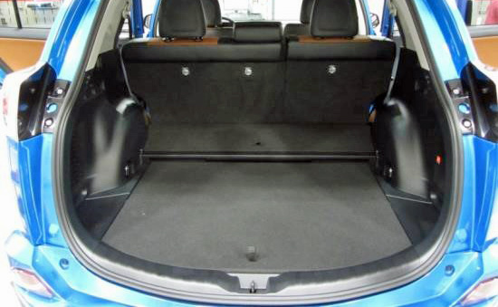
  - Remove the deck board (Fig. 1-1).
Fig. 1-1
Deck board

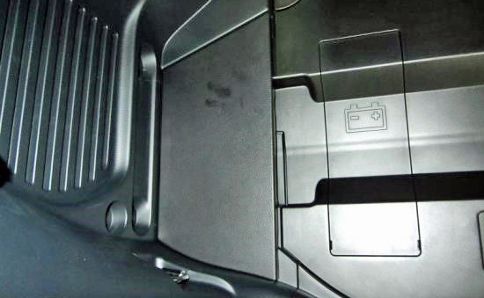
  - Remove the No. 3 deck board (Fig. 1-2).
Fig. 1-2
No. 3 deck board
asdf
asdf
Trim removal tool
Clip x 2
asdf

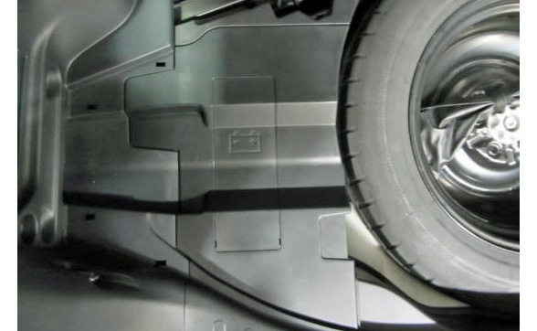
  - Remove the battery deck trim cover (Fig. 1-3).
Fig. 1-3
Battery deck trim cover
asdf
asdf
Trim removal tool
asdf
asdf
asdf
Clip x 5
asdf

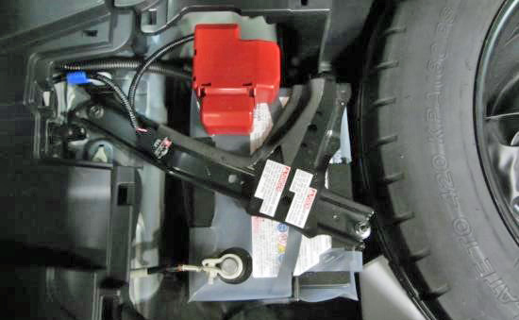
  - Disconnect the negative (-) battery terminal from the battery (Fig. 1-4).
Fig. 1-4
10mm wrench or socket & ratchet
NOTE: Isolate the negative battery terminal.

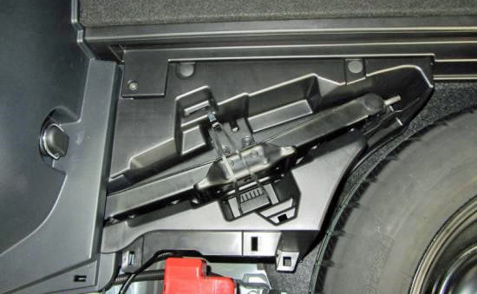
  - Remove the No. 2 tool box (Fig. 1-5).
Fig. 1-5
No. 2 tool box
asdf
Trim removal tool
asdf
asdf
asdf
Clip x 2
asdf
Push pin x 2
asdf

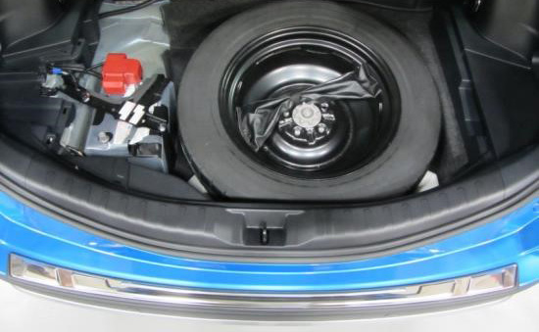
  - Remove the rear floor finish plate (Fig. 1-6).
Fig. 1-6
Rear floor finish plate
asdf
asdf
Trim removal tool
asdf
asdf
Clip x 4
asdf

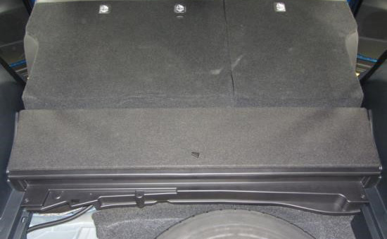
  - Lower the rear seats and remove the rear floor mat support side plate (Fig. 1-7).
Fig. 1-7
Rear floor mat support side plate
asdf
asdf
Trim removal tool, #2 Phillips screwdriver
asdf
asdf
asdf
asdf
asdf
Push pin x 7
asdf
Screw x 4

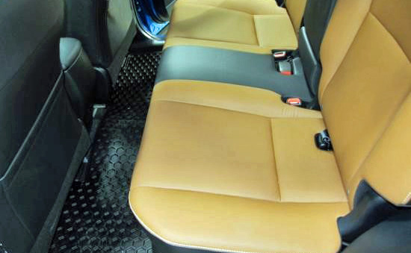
  - Raise the rear seats and remove the rear seat cushion by lifting the front to release the clips (Fig. 1-8).
Fig. 1-8
Rear seat cushion
asdf
asdf
Clip x 2
asdf

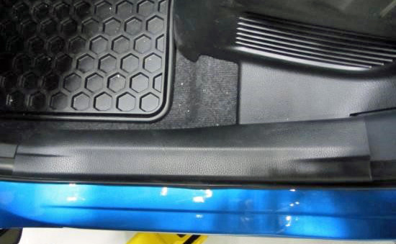
  - Remove the LH and RH rear door scuff plate (Fig. 1-9). LH side shown, repeat on the RH side.
Fig. 1-9
Rear door scuff plate
asdf
asdf
Trim removal tool
Clip x 2
asdf
Claw x 6

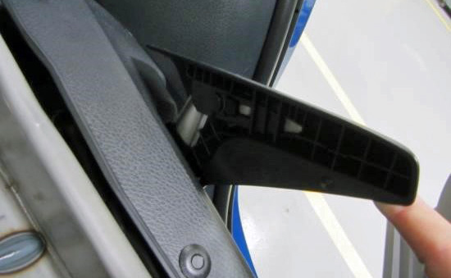
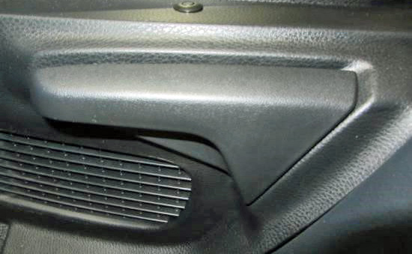
  - Remove the LH and RH rear seat recliner release handle (Fig. 1-10 & Fig. 1-11). LH side shown, repeat on the RH side.
Fig. 1-11
asdf
Fig. 1-10
Rear seat recliner release handle
asdf
Clip x 1
asdf

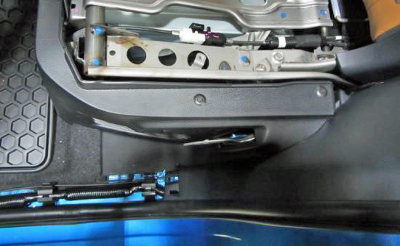
  - Remove the LH and RH battery service cover (Fig. 1-12). LH side shown, repeat on the RH side.
Fig. 1-12
Battery service cover
asdf
Trim removal tool
asdf
asdf
asdf
Clip x 2
asdf
Push pin x 7
asdf

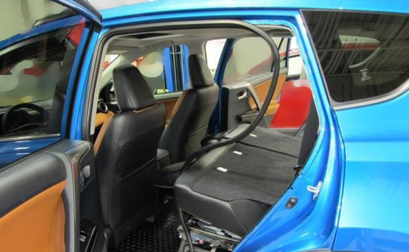
Fig. 1-13
  - Lower the rear seat backs and partially remove the LH and RH rear door weather strip (Fig. 1-13). LH side shown, repeat on the RH side.

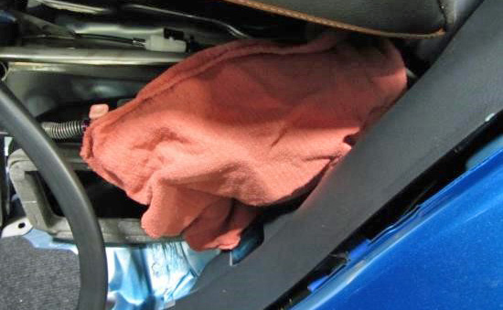
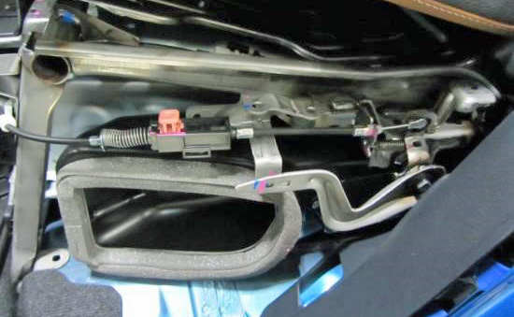
  - Wrap the LH and RH rear seat recliner handles with shop cloths to prevent damage (Fig. 1-14 & Fig. 1-15). LH side shown, repeat on the RH side.
Fig. 1-15
Fig. 1-14

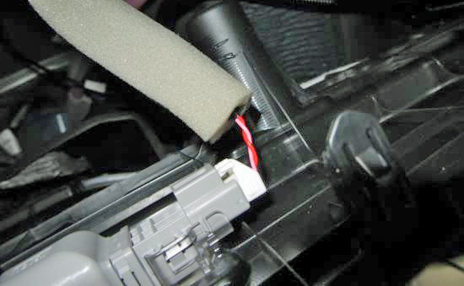
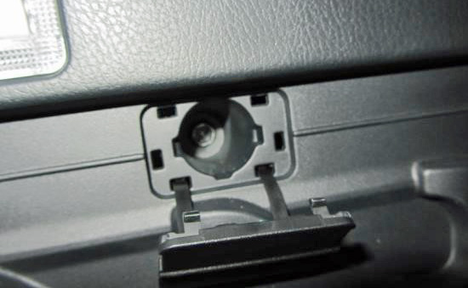
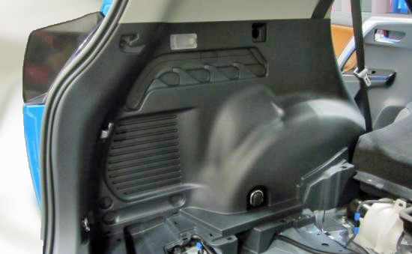
  - Remove the LH and RH deck trim side panel (Fig. 1-16 to Fig. 1-18). Disconnect any connectors. LH side shown, repeat on the RH side.
Fig. 1-18
Disconnect
Fig. 1-17
Fig. 1-16
Deck trim side panel
asdf
asdf
Trim removal tool, #2 Phillips screwdriver, 10mm & 14mm sockets, ratchet, extension
asdf
asdf
asdf
asdf
asdf
asdf
asdf
asdf
Fig. 1-18
Fig. 1-17
Clip x 10
asdf
Screw x 1
Bolt x 4

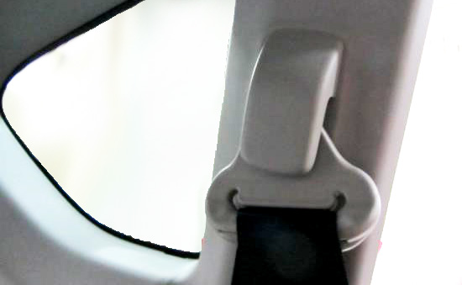
  - Remove the LH and RH seat belt anchor cover cap (Fig. 1-19). LH side shown, repeat on the RH side.
Fig. 1-19
Seat belt anchor cover cap
Trim removal tool
Claw x 2

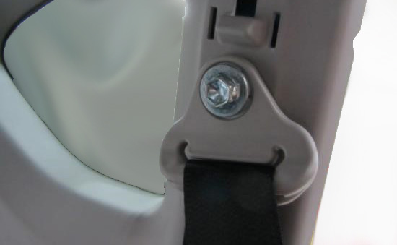
  - Remove the LH and RH rear seat belt anchor (Fig. 1-20). LH side shown, repeat on the RH side.
Fig. 1-20
14mm socket, ratchet extension
Bolt x 1

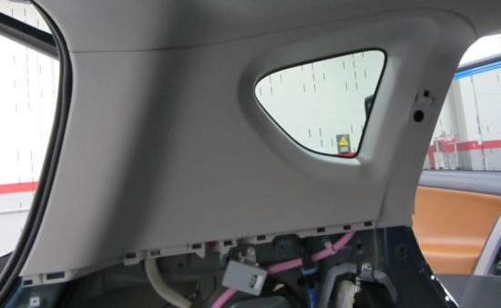
  - Remove the LH and RH roof side garnish (Fig. 1-21). LH side shown, repeat on the RH side.
Fig. 1-21
Roof side garnish
asdf
asdf
Trim removal tool
asdf
asdf
asdf
asdf
asdf
asdf
asdf
Clip x 9
asdf

Install the Trailer Harness Module.
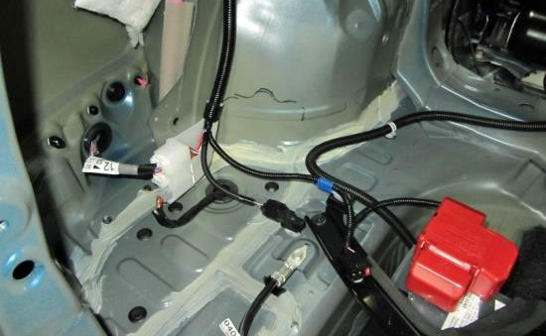
  - Clean the LH rear wheel house area shown in Fig. 2-1 with a locally approved cleaner.
Fig. 2-1
  - Peel off the tape backing strips from the trailer harness module.

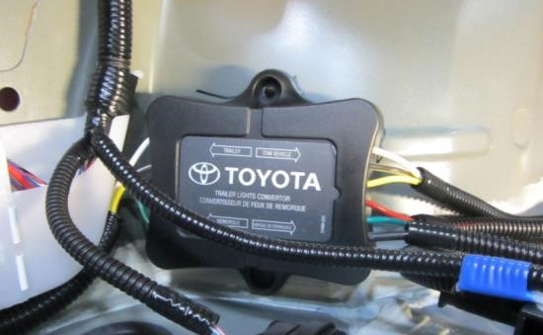
  - Use the reference dimension shown in Fig. 2-2 and apply pressure to secure the trailer harness module to the LH rear wheel house area.
Fig. 2-2
Tape measure
60 mm
Align
NOTE: Be sure to leave sufficient clearance to the module for the LH deck trim side panel to be reinstalled.

Install the Trailer Wire Harness.
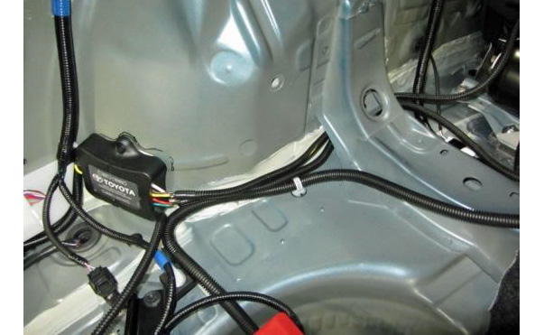
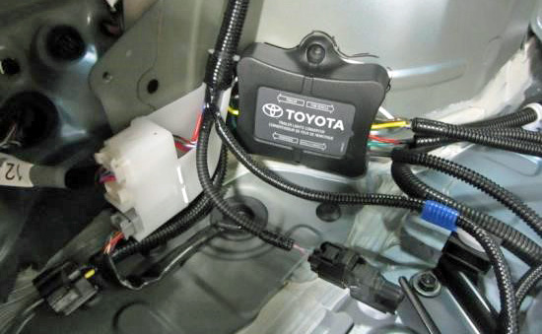
  - Route the trailer wire harness (Fig. 3-1 to Fig. 3-2).
B
D
C
Fig. 3-2
Fig. 3-1
A
    - Route the white, brown, yellow & green and green wires (A) towards the tow hitch.
    - Route the white, brown and yellow wires with a ground ring (B) towards the LH rear combination lamp.
    - Route the red and green wires (C - Longest) towards RH rear combination lamp.
    - Route the black wire with the fuse (D) towards the battery.

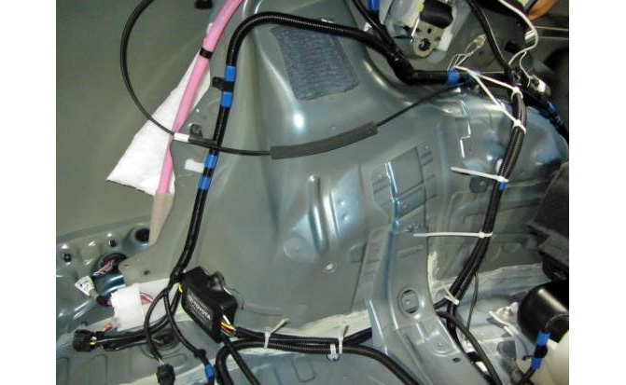
  - Secure the trailer wire harness (B and C) to the vehicle harness with 8” wire ties 1 and 2 (Fig. 3-3).
Fig. 3-3
1
2
4
5
6
7
3
B
C
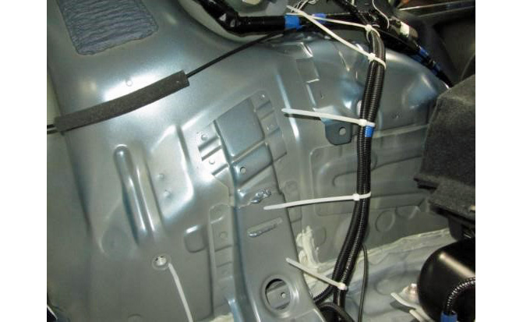
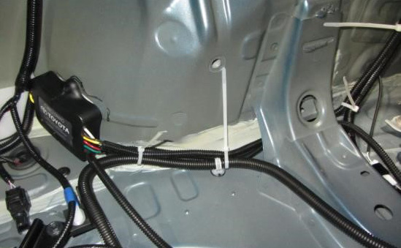
  - Secure the trailer wire harness (B) to the vehicle harness with 8” wire ties 3 to 7 (Fig. 3-3 to Fig. 3-5).
Fig. 3-5
3
4
5
7
6
B
Fig. 3-4
1
2
3
B
C

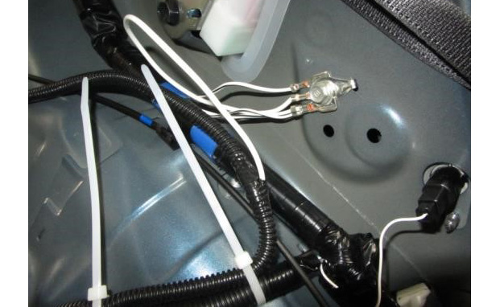
  - Secure the trailer wire harness (B) ground terminal to the vehicle with the original ground bolt (Fig. 3-6).
10mm socket, ratchet, torque wrench, extension
Fig. 3-6
B
Bolt x 1
Torque: 8.4 N-m (74 in-lbf)

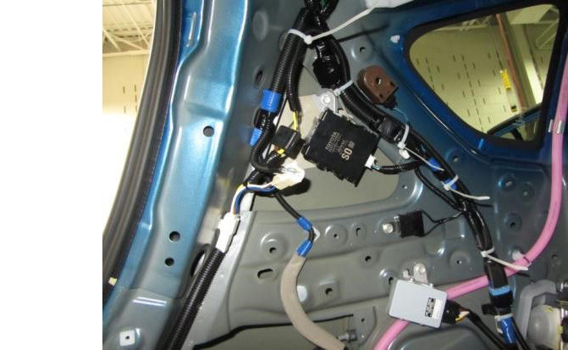
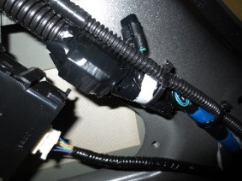
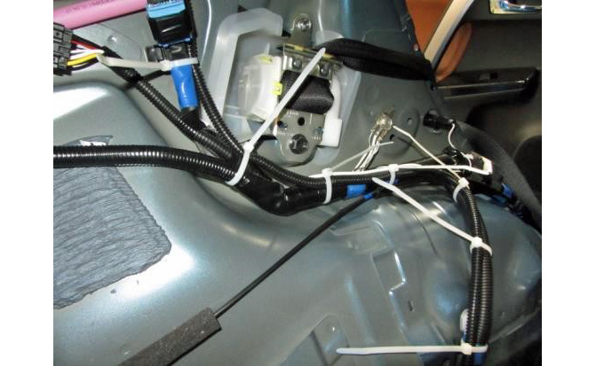
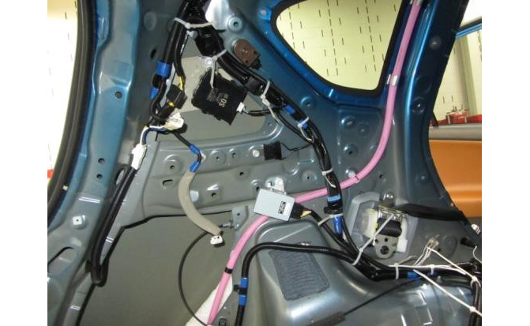
  - Secure the trailer wire harness (B) to the vehicle harness with 8” wire ties 8 to 16 (Fig. 3-7 to Fig. 3-9).
Fig. 3-9
11
12
13
14
15
16
B
Fig. 3-8
5
6
7
8
9
10
11
B
Fig. 3-7
7
6
8
10
9
11
12
13
14
15
16
B
    - The #9 wire tie latch must be pointed down, away from the ground wire.
    - The #15 wire tie latch must be installed away from the OE splice junction (Fig. 3-9 inset).
NOTE: Do not secure the trailer wire harness (B) to the water hose, which must be free for proper operation.

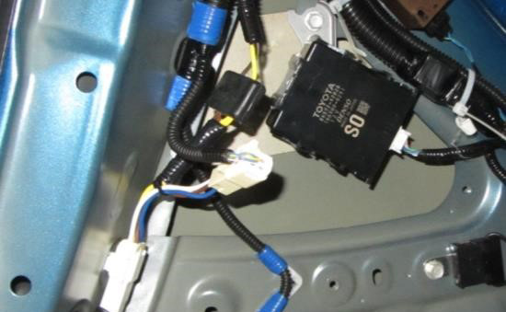
  - Plug the trailer wire harness (B) T-connection 4-pin male connector (with white, brown, yellow and blue wires) to the 4-pin female connector from the vehicle LH rear combination lamp (Fig. 3-10).
Fig. 3-10
B
Trailer wire harness (B) T-connection
Vehicle harness 4-pin male connector
Vehicle LH RR combination lamp 4-pin female connector
  - Plug the trailer wire harness (B) T-connection 4-pin female connector to the 4-pin male connector from the vehicle harness (Fig. 3-10).

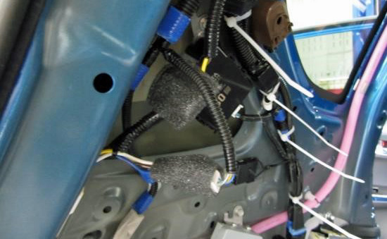
  - Wrap the plastic junction block of the trailer wire harness (B) and the loose vehicle harness 4-pin connector with foam pads (Fig. 3-11).
Fig. 3-11
4-pin connector to vehicle harness
Trailer wire harness junction block

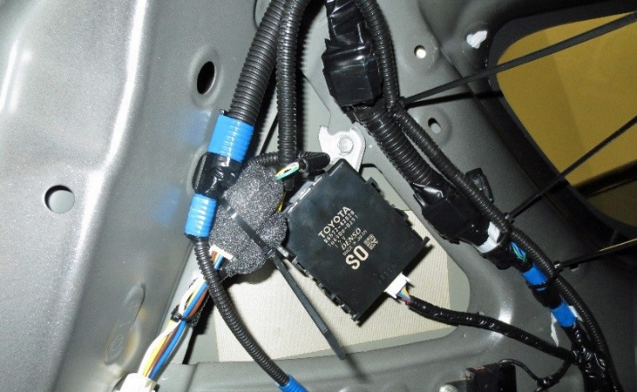
  - Bundle the plastic junction block of the trailer wire harness (B) and the loose vehicle harness 4-pin connector with 8” wire tie 17 (Fig. 3-12).
Fig. 3-12
17
15
14
13
B

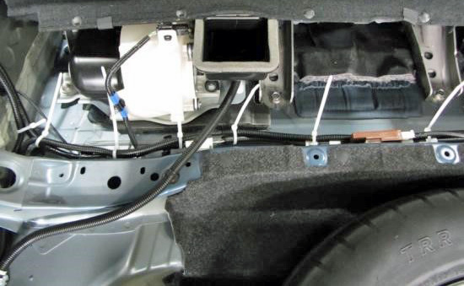
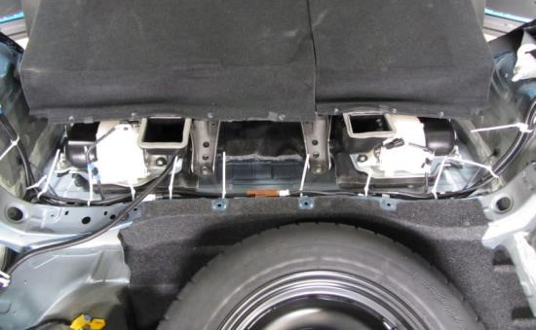
  - Secure the trailer wire harness (C) to the vehicle harness with 8” wire ties 18 to 23 (Fig. 3-13 to Fig. 3-14).
Fig. 3-14
3
18
19
20
21
22
23
C
B
Fig. 3-13
4
3
18
19
20
21
22
23
24
25
26
27
C
B

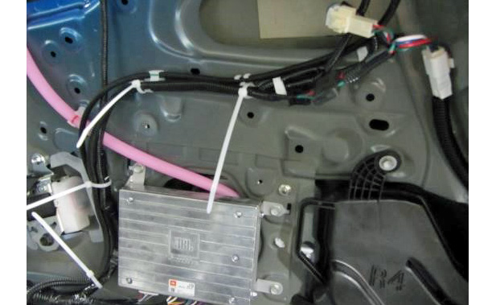
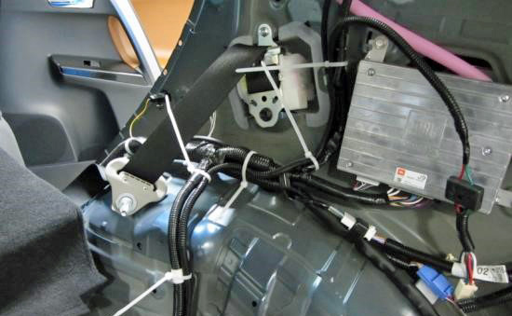
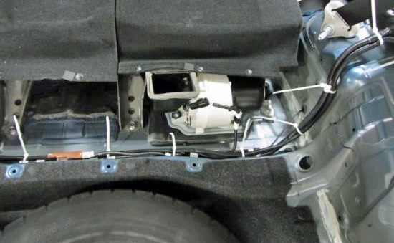
  - Secure the trailer wire harness (C) to the vehicle harness with 8” wire ties 22 to 33 (Fig. 3-15 to Fig. 3-17).
33
30
31
32
C
Fig. 3-17
Fig. 3-16
28
29
30
31
27
C
Fig. 3-15
28
22
23
24
25
26
27
C
NOTE: The #28-33 wire tie latches must be positioned away from all drain hoses along the wire path.

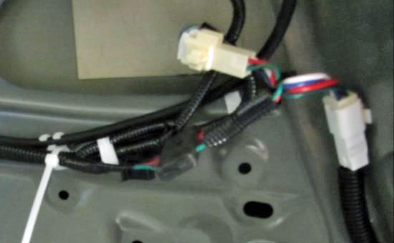
  - Plug the trailer wire harness (C) T-connection 4-pin male connector (with red, green, white and blue wires) to the 4-pin female connector from the vehicle RH rear combination lamp (Fig. 3-18).
Fig. 3-18
C
Trailer wire harness (C) T-connection
Vehicle harness 4-pin male connector
Vehicle RH RR combination lamp 4-pin female connector
33
  - Plug the trailer wire harness (C) T-connection 4-pin female connector to the 4-pin male connector from the vehicle harness (Fig. 3-18).

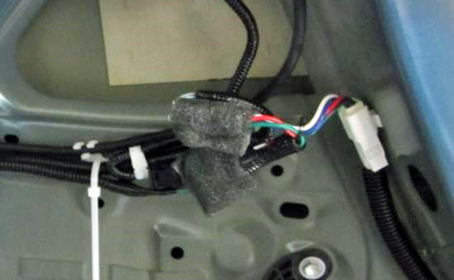
  - Wrap the plastic junction block of the trailer wire harness (C) and the loose vehicle harness 4-pin connector with foam pads (Fig. 3-19).
Fig. 3-19
4-pin connector to vehicle harness
Trailer wire harness junction block

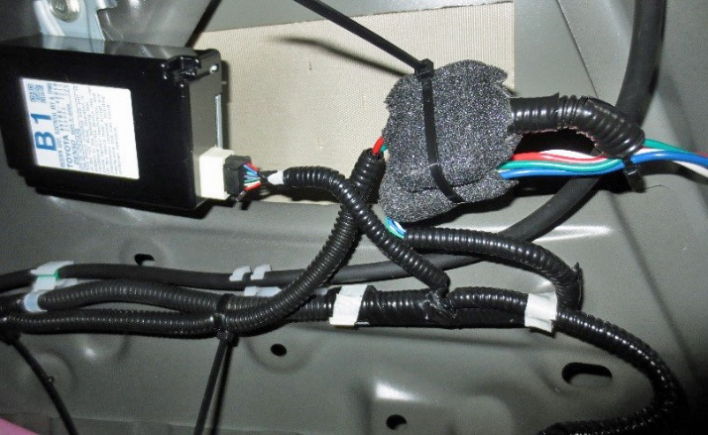
  - Bundle the plastic junction block of the trailer wire harness (C) and the loose vehicle harness 4-pin connector with 8” wire tie 34 (Fig. 3-20).
33
34
C
Fig. 3-20

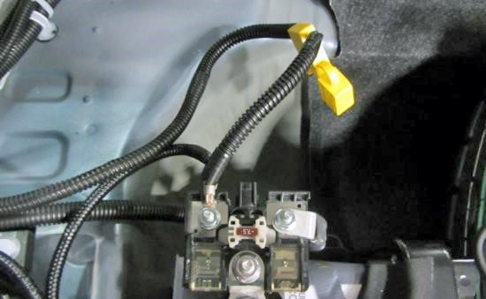
  - Remove the positive (+) battery cover and 15A fuse from the trailer wire harness (D). Connect the trailer wire harness (D) to the B+ battery terminal (Fig. 3-21).
Fig. 3-21
D
Remove 15A fuse

Nut x 1
Torque: 5.4 N-m (48 in-lbf)

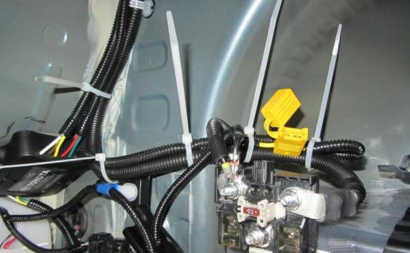
  - Secure the trailer wire harness (D) to the vehicle harness with 8” wire ties 35 to 38 (Fig. 3-22).
Fig. 3-22
1
38
37
36
35
C
B
D

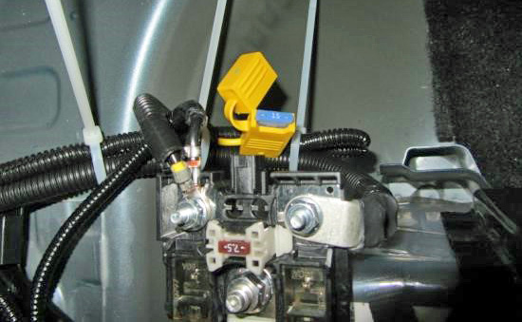
  - Reinstall the 15A fuse to the trailer wire harness (D) (Fig. 3-23).
Fig. 3-23
D
15A fuse

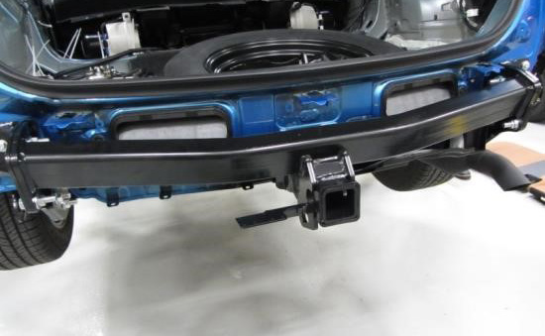
  - Install the tow hitch before proceeding (Fig. 3-24). Refer to the tow hitch installation instructions.
Fig. 3-24

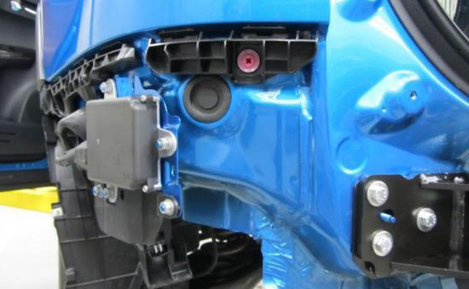
  - Remove the vehicle hole plug located below the LH rear combination lamp (Fig. 3-25).
Fig. 3-25
Hole plug

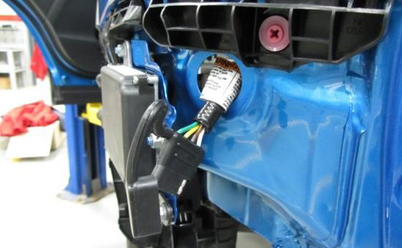
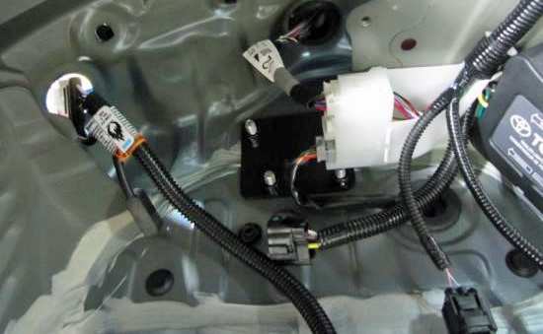
  - Route the 4-flat trailer wire harness through the vehicle hole (Fig. 3-26 to Fig. 3-27).
Fig. 3-27
4-flat trailer harness
Fig. 3-26
4-flat trailer harness

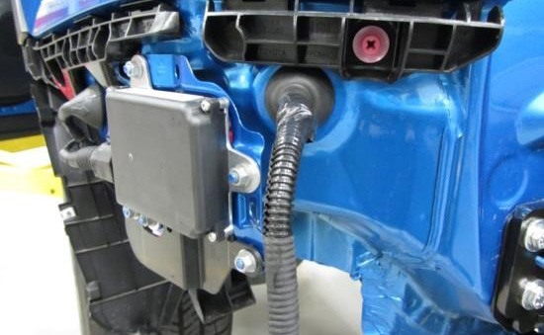
  - Ensure that the 4-flat trailer wire harness grommet is fully seated to the vehicle body (Fig. 3-28).
Fig. 3-28
4-flat trailer harness grommet

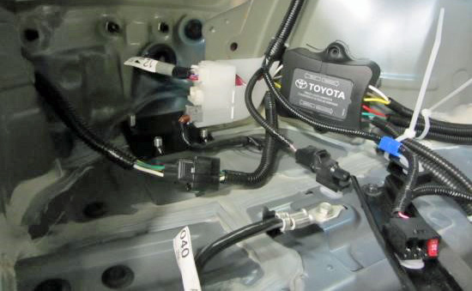
  - Plug the 4-flat trailer wire harness to the trailer wire harness (A) (Fig. 3-29).
Fig. 3-29
A
4-flat trailer harness

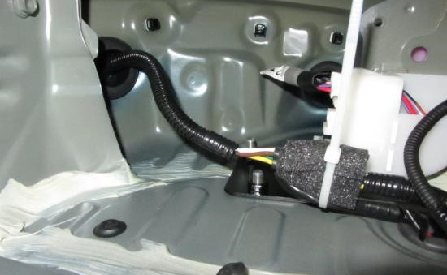
  - Wrap the connector with a foam pad and secure it to the vehicle harness with wire tie 39 (Fig. 3-30).
Fig. 3-30
A
4-flat trailer harness
39

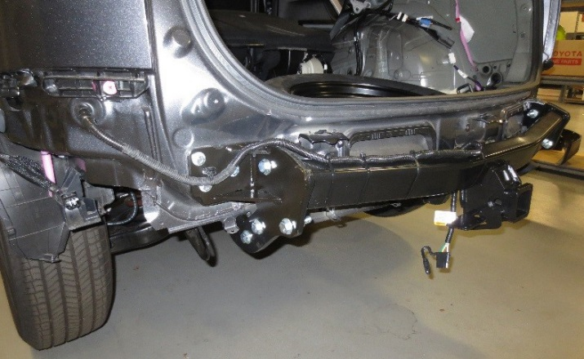
  - Route and secure the 4-flat trailer wire harness to the tow hitch with the stud mount clip and 8” wire tie 40 and 14” wire ties 41 to 44 (Fig. 3-31).
Fig. 3-31
44
40
41
42
43
M6 stud mount clip
4-flat trailer harness

M6 stud mount clip x 1
  - Cut off the excess from the wire ties.

Modify the LH Undercover.
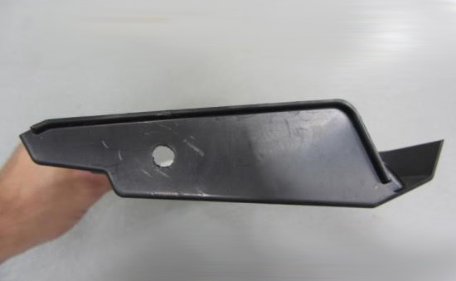
  - Drill the LH undercover with a 7.5 mm drill bit in the location shown in Fig. 4-1).
Fig. 4-1
15mm
15mm
  - Reinstall the modified rear bumper fascia and undercovers before proceeding. Refer to the tow hitch installation instructions.

Mount the Trailer Harness Connector.
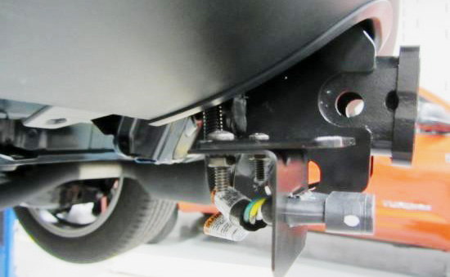
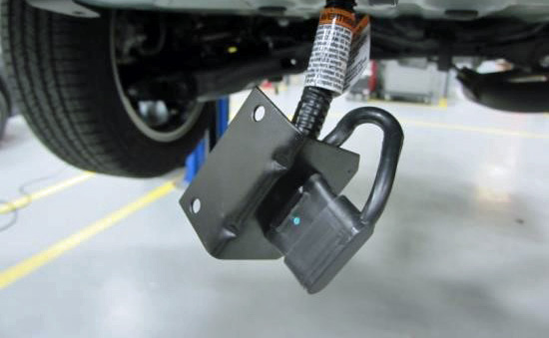
  - Assemble the 4-flat trailer wire harness to the L-shape bracket and attach it to the tow hitch (Fig. 5-1 to Fig. 5-2).
Fig. 5-2
Fig. 5-1
4-flat trailer harness
L-shape bracket

Screw x 2

Nut/Washer x 2

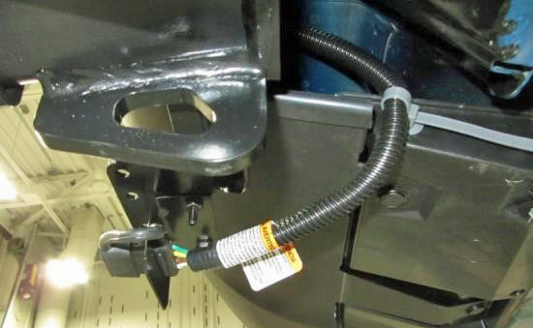
  - Secure the 4-flat trailer wire harness to the LH undercover with the push mount clip (Fig. 5-3).
Fig. 5-3
Push mount clip
4-flat trailer harness

Push mount clip x 1
  - Cut off the excess from the push mount clip.

Reassemble the Vehicle.
  - Reinstall the components removed in Step 1 in reverse order.
  - Verify the trim panels fit together properly with no uneven gaps between them.
  - The bolt torque for the seat belt anchor is 42 N-m (31 in-lbf).
Torque: 42 N-m (31 in-lbf)

  - The bolt torque for the negative battery terminal is 5.4 N-m (48 ft-lbf).
Torque: 5.4 N-m (48 in-lbf)
  - Place the installation instructions, fuse location card, and owner’s manual in the glove box for future reference.
  - Perform the functional check for the trailer wire harness and the post installation check for the vehicle. Refer to the attached checklist.
WARNING: Overloading the circuit can cause a fire. DO NOT exceed the load of the towing manufacturer rating or:
- Maximum stop/turn light: 2 bulbs per side (total 4.2 amps)
- Maximum tail lights: 7.5 amps
  - Read the vehicle owner’s manual and instruction sheet for additional information.
  - Clean up and remove any trash.

Accessory Function Checks
Right turn signal
Left turn signal
Brake
Tail light
Tail light & brake
Left turn & brake
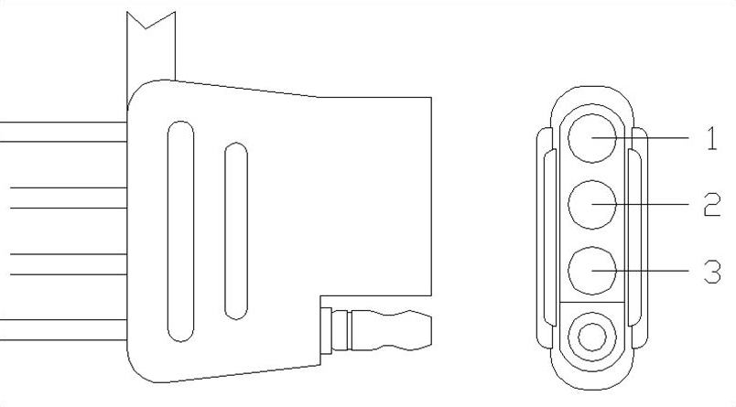
Right turn & brake

Vehicle Function Checks
Individual vehicle light functions

Trunk light
Warning lights
Front wipers & washers

Circuit 1 flashes
Circuit 2 flashes
Circuit 1 & 2 activate
Circuit 3 activates
Circuit 1, 2 & 3 activate
Circuit 1 activates & 2 flashes
Circuit 1 flashes & 2 activates

Verify that the corresponding vehicle lights activate. If light does not activate then check the connection.
Functions normally
No warning lights illuminated in the combination meter
Operate the front wiper while spraying washer fluid onto the windshield glass. Make sure that the front wiper functions properly and the wiper does not come into contact with the vehicle body.
Lift each front wiper blade twice after the front wipers stop and check the wiper set position.
Vehicle Appearance Check
After accessory installation and removal of protective cover(s), perform a visual inspection.

Failure Mode
- No power to the trailer light functions

Corrosion on the 4-flat plug

Ensure no damage (including scuffs and scratches) was caused during the installation process.
(For PPO installations, refer to TMS Accessory Quality Shipping Standard.)

Troubleshooting Steps
- Check the trailer wiring harness fuse per the owner’s manual fuse location card.
- Check the 4-flat connection between the trailer and the vehicle to ensure the connection is fully engaged.
- Turn all functions off and remove the key for 10 seconds and retest the functions with the trailer attached.
- Turn all functions off and remove the key for 10 seconds with the trailer disengaged. Use a multi-meter to check the function output at the 4-flat. If all functions work, check the trailer for a potential short or overload described in the owner’s manual fuse location card.

Clean the connection and add Dielectric Grease (sold separately) to the terminal pins.

